1. **Top 5 Most Enrolled Courses**

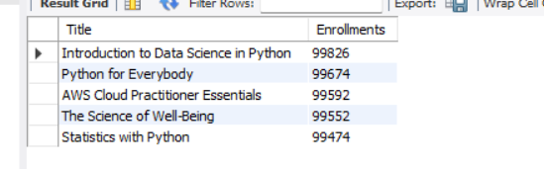

1. **Average Rating by Category**

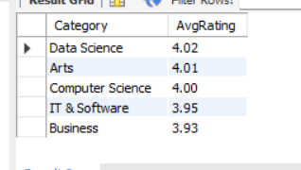

1. **Paid vs Free Course Count**

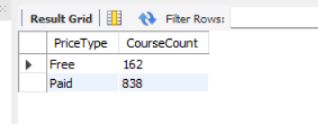

1. **Top Instructors by Average Rating**

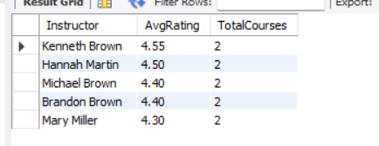

1. **Platforms Offering High-Rated & Highly Enrolled Courses**

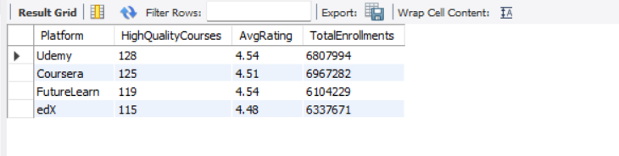

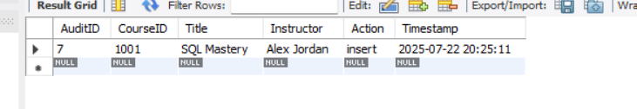

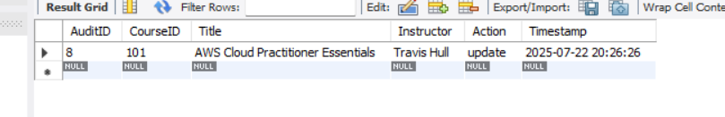

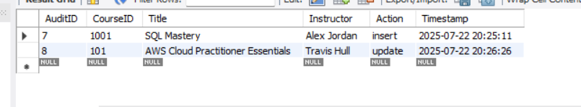

**To export, right-click result grid → Export to CSV in MySQL Workbench**